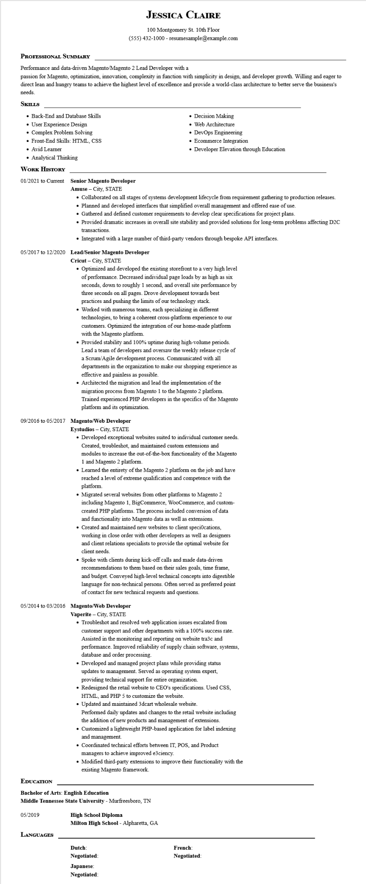
PROFESSIONAL SUMMARY
JESSICA CLAIRE
100 Montgomery St. 10th Floor
(555) 432-1000 - resumesample@example.com
Performance and data-driven Magento/Magento 2 Lead Developer with a
passion for Magento, optimization, innovation, complexity in function with simplicity in design, and developer growth. Willing and eager to direct lean and hungry teams to achieve the highest level of excellence and provide a world-class architecture to better serve the business's needs.
SKILLS
• Back-End and Database Skills
• User Experience Design
• Complex Problem Solving
• Front-End Skills: HTML, CSS
• Avid Learner
• Analytical Thinking
WORK HISTORY
01/2021 to Current Senior Magento Developer Amuse - City, STATE
• Decision Making
• Web Architecture
• DevOps Engineering
• Ecommerce Integration
• Developer Elevation through Education
• Collaborated on all stages of systems development lifecycle from requirement gathering to production releases.
• Planned and developed interfaces that simplified overall management and offered ease of use.
• Gathered and defined customer requirements to develop clear specifications for project plans.
• Provided dramatic increases in overall site stability and provided solutions for long-term problems affecting D2C transactions
• Integrated with a large number of third-party vendors through bespoke API interfaces.
05/2017 to 12/2020 Lead/Senior Magento Developer
Cricut - City, STATE
• Optimized and developed the existing storefront to a very high level of performance. Decreased individual page loads by as high as six seconds, down to roughly 1 second, and overall site performance by three seconds on all pages. Drove development towards best practices and pushing the limits of our technology stack.
• Worked with numerous teams, each specializing in different technologies, to bring a coherent cross-platform experience to our customers. Optimized the integration of our home-made platform with the Magento platform.
• Provided stability and 100% uptime during high-volume periods. Lead a team of developers and oversaw the weekly release cycle of a Scrum/Agile development process. Communicated with all departments in the organization to make our shopping experience as effective and painless as possible.
• Architected the migration and lead the implementation of the
migration process from Magento 1 to the Magento 2 platform. Trained experienced PHP developers in the specifics of the Magento platform and its optimization.
09/2016 to 05/2017 Magento/Web Developer
Eystudios - City, STATE
• Developed exceptional websites suited to individual customer needs. Created, troubleshot, and maintained custom extensions and modules to increase the out-of-the-box functionality of the Magento 1 and Magento 2 platform.
• Learned the entirety of the Magento 2 platform on the job and have reached a level of extreme qualification and competence with the platform.
• Migrated several websites from other platforms to Magento 2 including Magento 1, BigCommerce, WooCommerce, and custom- created PHP platforms. The process included conversion of data and functionality into Magento data as well as extensions. • Created and maintained new websites to client speci0cations, working in close order with other developers as well as designers and client relations specialists to provide the optimal website for client needs.
·
Spoke with clients during kick-off calls and made data-driven recommendations to them based on their sales goals, time frame, and budget. Conveyed high-level technical concepts into digestible language for non-technical persons. Often served as preferred point of contact for new technical requests and questions.
05/2014 to 03/2016 Magento/Web Developer
Vaperite - City, STATE
• Troubleshot and resolved web application issues escalated from customer support and other departments with a 100% success rate. Assisted in the monitoring and reporting on website tra3c and performance. Improved reliability of supply chain software, systems, database and order processing.
• Developed and managed project plans while providing status updates to management. Served as operating system expert, providing technical support for entire organization.
• Redesigned the retail website to CEO's specifications. Used CSS,
HTML, and PHP 5 to customize the website.
• Updated and maintained 3dcart wholesale website.
Performed daily updates and changes to the retail website including
the addition of new products and management of extensions.
• Customized a lightweight PHP-based application for label indexing
and management.
• Coordinated technical efforts between IT, POS, and Product managers to achieve improved e3ciency.
• Modified third-party extensions to improve their functionality with the existing Magento framework.
EDUCATION
Bachelor of Arts: English Education
Middle Tennessee State University - Murfreesboro, TN
05/2019
High School Diploma
Milton High School - Alpharetta, GA
LANGUAGES
Dutch: Negotiated:
Japanese:
Negotiated:
French: Negotiated:

